School Code:-61591 Affiliation no:-2134030
REGALS ACADEMY SENIOR SECONDARYSCHOOL
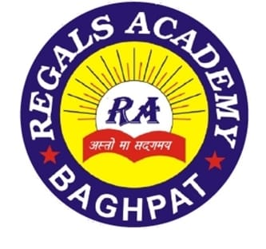
Affiliated to CBSE
Khatta – Daula Link Road
Khatta Prahladpur (Baghpat)

Manager Principal
Ad. Ajay Khokhar Ms. Meera

S.NO. | Fee Structure | Tution Fee
1 | NUR | 1100
2 | K.G. | 1100
3 | I | 1200
4 | II | 1200
5 | III | 1300
6 | IV | 1300
7 | V | 1400
8 | VI | 1400
9 | VII | 1500
10 | VIII | 1600
11 | IX | 2000
12 | X | 2200
13 | XI | 3000
14 | XII | 3500

